**PRACTICAL 2**

**Write a program using the folloeing system calls of UNIX operating system: fork, exec, getpid, exit, wait, stat, readdir, opendir.**

**Aim:**

**Task-01 Write a program to execute fork() and find out the process id by getpid() system call.**

**Program:**

**File 1: prac2.c**

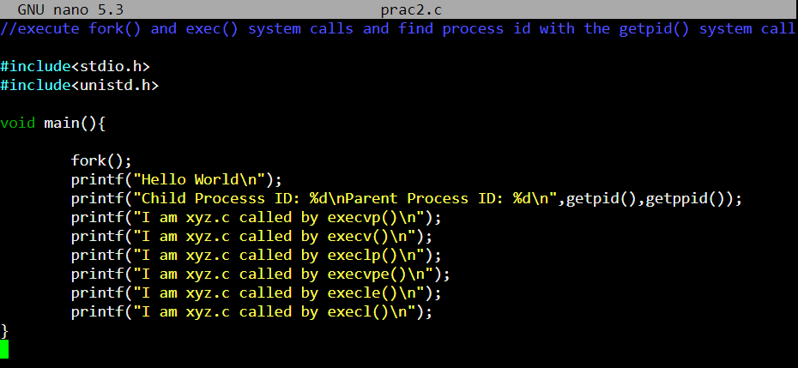

**File 2: xyz.c**

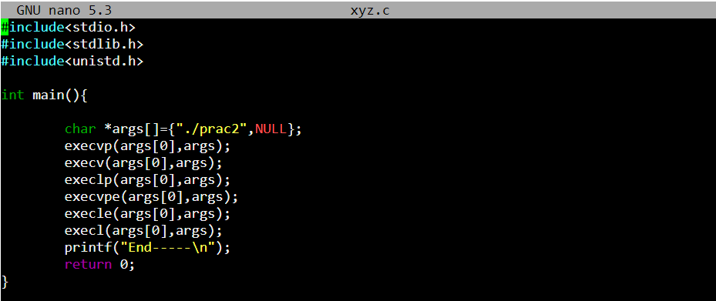

**Output:**

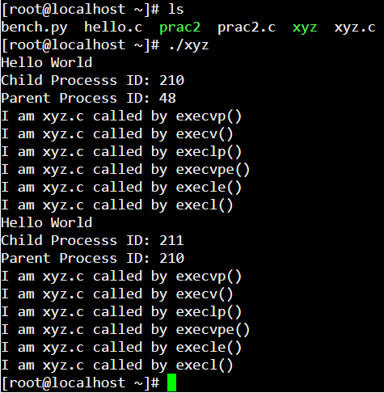

**Conclusion:**

In this practical we have learnt about fork(), getpid() and getppid(), exec() system calls.